**INTRODUCTION**

The Sustainable Forestry Initiative® (SFI) [2022 Standards](https://forests.org/sfi-2022-standards/) include requirements that promote and conserve Forests with Exceptional Conservation Value (FECV), which includes critically imperiled (G1) and imperiled (G2) species. This fact sheet summarizes the analysis of FECV habitat within this ecoregion and provides habitat management recommendations that would benefit species potentially found here.   
  
**HABITAT TYPES**

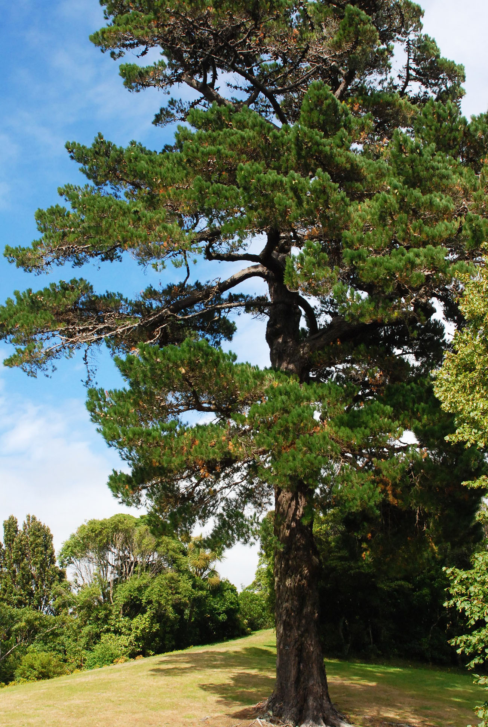**Monterey Pine**

**Humboldt Milkvetch**

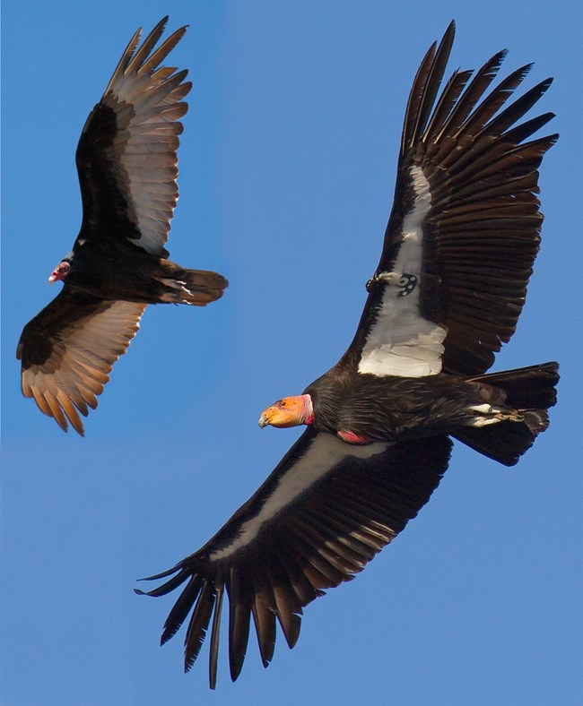

**California Condor**

* Grassland
* Mixed Conifer Forest
* Riparian/Stream/Wetland
* Shrubland/Chaparral
* Special Sites (Bare Rock/Talus, Barrens, Bog/Fen, Cliff, Forest Edge, Sand/Dune, Temporary Pools)

**GRASSLAND MANAGEMENT**

* Protect known locations
* Buffer grassland areas

**MIXED CONIFER FOREST MANAGEMENT**

* Protect known locations
* Retain legacy trees, stumps, and logs
* Retain large diameter trees with cavities or broken tops
* Leave skips and gaps with dense shrub component
* Retain large slash into piles

**RIPARIAN/STREAMS/WETLAND MANAGEMENT**

* Protect known locations
* Maintain well vegetated riparian buffers
* Plant a diversity of both hardwood and conifer trees
* Retain large diameter trees near streams, rivers and wetlands
* Buffer wetlands, springs, and headwater areas

**SHRUBLAND/CHAPARRAL**

* Protect known locations
* Buffer shrubland and chaparral areas

**SPECIAL SITES MANAGEMENT**

* Protect known locations
* Maintain and buffer special sites

| **SCIENTIFIC NAME** | **COMMON NAME** | **HABITAT** | **STATUS** |
| --- | --- | --- | --- |
| *Hypogymnia schizidiata* | Island Tube Lichen | Bare Rock/Talus | G1 |
| *Eriogonum cedrorum* | [The Cedars Buckwheat](https://explorer.natureserve.org/Taxon/ELEMENT_GLOBAL.2.836576) | Bare Rock/Talus | G1 |
| *Orthotrichum kellmanii* | [Kellman's Bristle Moss](https://explorer.natureserve.org/Taxon/ELEMENT_GLOBAL.2.736783) | Bare Rock/Talus | G2 |
| *Dacryophyllum falcifolium* | [Teardrop Moss](https://explorer.natureserve.org/Taxon/ELEMENT_GLOBAL.2.795615) | Bare Rock/Talus | G2 |
| *Trifolium amoenum* | Showy Indian Clover | Barrens | G1 |
| *Arenaria paludicola* | Marsh Sandwort | Bog/Fen | G1 |
| *Gymnogyps californianus* | California Condor | Cliff | G1 |
| *Eriophyllum latilobum* | [San Mateo Woolly-sunflower](https://explorer.natureserve.org/Taxon/ELEMENT_GLOBAL.2.138202) | Forest Edge | G1 |
| *Fritillaria grayana* | [Gray's Fritillary](https://explorer.natureserve.org/Taxon/ELEMENT_GLOBAL.2.155268) | Grassland | G1 |
| *Agrostis blasdalei* | [Cliff Bentgrass](https://explorer.natureserve.org/Taxon/ELEMENT_GLOBAL.2.147690) | Grassland | G2 |
| *Bombus crotchii* | Crotch's Bumble Bee | Grassland | G2 |
| *Adela oplerella* | [Opler's Longhorn Moth](https://explorer.natureserve.org/Taxon/ELEMENT_GLOBAL.2.114295) | Grassland | G2 |
| *Trifolium trichocalyx* | [Monterey Clover](https://explorer.natureserve.org/Taxon/ELEMENT_GLOBAL.2.146375) | Mixed Conifer Forest | G1 |
| *Pinus radiata* | [Monterey Pine](https://explorer.natureserve.org/Taxon/ELEMENT_GLOBAL.2.147411) | Mixed Conifer Forest | G1 |
| *Arctostaphylos ohloneana* | [Ohlone Manzanita](https://explorer.natureserve.org/Taxon/ELEMENT_GLOBAL.2.826799) | Mixed Conifer Forest | G1 |
| *Trifolium polyodon* | [Pacific Grove Clover](https://explorer.natureserve.org/Taxon/ELEMENT_GLOBAL.2.132041) | Mixed Conifer Forest | G1 |
| *Arctostaphylos glutinosa* | [Schreiber's Manzanita](https://explorer.natureserve.org/Taxon/ELEMENT_GLOBAL.2.137569) | Mixed Conifer Forest | G1 |
| *Arctostaphylos silvicola* | [Silverleaf Manzanita](https://explorer.natureserve.org/Taxon/ELEMENT_GLOBAL.2.147236) | Mixed Conifer Forest | G1 |
| *Argynnis adiaste* | [Unsilvered Fritillary](https://explorer.natureserve.org/Taxon/ELEMENT_GLOBAL.2.108911) | Mixed Conifer Forest | G1 |
| *Trimerotropis infantilis* | [Zayante Band-winged Grasshopper](https://explorer.natureserve.org/Taxon/ELEMENT_GLOBAL.2.112695) | Mixed Conifer Forest | G1 |
| *Sedum citrinum* | [Blue Creek Stonecrop](https://explorer.natureserve.org/Taxon/ELEMENT_GLOBAL.2.947367) | Mixed Conifer Forest | G2 |
| *Arctostaphylos virgata* | [Bolinas Manzanita](https://explorer.natureserve.org/Taxon/ELEMENT_GLOBAL.2.156697) | Mixed Conifer Forest | G2 |
| *Lilium maritimum* | [Coast Lily](https://explorer.natureserve.org/Taxon/ELEMENT_GLOBAL.2.140403) | Mixed Conifer Forest | G2 |
| *Lessingia arachnoidea* | [Crystal Springs Lessingia](https://explorer.natureserve.org/Taxon/ELEMENT_GLOBAL.2.145853) | Mixed Conifer Forest | G2 |
| *Cupressus goveniana* | Gowen Cypress | Mixed Conifer Forest | G2 |
| *Streptanthus howellii* | [Howell's Jewelflower](https://explorer.natureserve.org/Taxon/ELEMENT_GLOBAL.2.152527) | Mixed Conifer Forest | G2 |
| *Astragalus agnicidus* | [Humboldt Milkvetch](https://explorer.natureserve.org/Taxon/ELEMENT_GLOBAL.2.132940) | Mixed Conifer Forest | G2 |
| *Linanthus jepsonii* | [Jepson's Desert-trumpets](https://explorer.natureserve.org/Taxon/ELEMENT_GLOBAL.2.144604) | Mixed Conifer Forest | G2 |
| *Arctostaphylos regismontana* | [Kings Mountain Manzanita](https://explorer.natureserve.org/Taxon/ELEMENT_GLOBAL.2.159466) | Mixed Conifer Forest | G2 |
| *Hoita strobilina* | [Loma Prieta Scurfpea](https://explorer.natureserve.org/Taxon/ELEMENT_GLOBAL.2.152898) | Mixed Conifer Forest | G2 |
| *Polites mardon* | [Mardon Skipper](https://explorer.natureserve.org/Taxon/ELEMENT_GLOBAL.2.115970) | Mixed Conifer Forest | G2 |
| *Chorizanthe pungens* | [Monterey Spineflower](https://explorer.natureserve.org/Taxon/ELEMENT_GLOBAL.2.156378) | Mixed Conifer Forest | G2 |
| *Streptanthus morrisonii* | [Morrison's Jewelflower](https://explorer.natureserve.org/Taxon/ELEMENT_GLOBAL.2.146484) | Mixed Conifer Forest | G2 |
| *Collinsia multicolor* | [San Francisco Collinsia](https://explorer.natureserve.org/Taxon/ELEMENT_GLOBAL.2.152979) | Mixed Conifer Forest | G2 |
| *Solanum wallacei* | [Santa Catalina Nightshade](https://explorer.natureserve.org/Taxon/ELEMENT_GLOBAL.2.131536) | Mixed Conifer Forest | G2 |
| *Arctostaphylos andersonii* | [Santa Cruz Manzanita](https://explorer.natureserve.org/Taxon/ELEMENT_GLOBAL.2.141166) | Mixed Conifer Forest | G2 |
| *Stebbinsoseris decipiens* | [Santa Cruz Silverpuffs](https://explorer.natureserve.org/Taxon/ELEMENT_GLOBAL.2.157632) | Mixed Conifer Forest | G2 |
| *Thermopsis robusta* | [Showy Golden-banner](https://explorer.natureserve.org/Taxon/ELEMENT_GLOBAL.2.138782) | Mixed Conifer Forest | G2 |
| *Streptanthus batrachopus* | [Tamalpais Streptanthus](https://explorer.natureserve.org/Taxon/ELEMENT_GLOBAL.2.150078) | Mixed Conifer Forest | G2 |
| *Calochortus raichei* | [The Cedars Fairylantern](https://explorer.natureserve.org/Taxon/ELEMENT_GLOBAL.2.143740) | Mixed Conifer Forest | G2 |
| [*Grimmia torenii*](https://explorer.natureserve.org/Taxon/ELEMENT_GLOBAL.2.885996) |  | Mixed Conifer Forest | G2 |
| *Rhynchospora californica* | [California Beakrush](https://explorer.natureserve.org/Taxon/ELEMENT_GLOBAL.2.134279) | Riparian/Streams | G1 |
| *Syncaris pacifica* | [California Freshwater Shrimp](https://explorer.natureserve.org/Taxon/ELEMENT_GLOBAL.2.109493) | Riparian/Streams | G1 |
| *Juga chacei* | [Chace Juga](https://explorer.natureserve.org/Taxon/ELEMENT_GLOBAL.2.758731) | Riparian/Streams | G1 |
| *Potentilla hickmanii* | [Hickman's Cinquefoil](https://explorer.natureserve.org/Taxon/ELEMENT_GLOBAL.2.151363) | Riparian/Streams | G1 |
| *Pomatiopsis binneyi* | [Robust Walker](https://explorer.natureserve.org/Taxon/ELEMENT_GLOBAL.2.114384) | Riparian/Streams | G1 |
| *Rana draytonii* | California Red-legged Frog | Riparian/Streams | G2 |
| *Ambystoma californiense* | [California Tiger Salamander](https://explorer.natureserve.org/Taxon/ELEMENT_GLOBAL.2.153012) | Riparian/Streams | G2 |
| *Legenere limosa* | [False Venus'-looking-glass](https://explorer.natureserve.org/Taxon/ELEMENT_GLOBAL.2.153012) | Riparian/Streams | G2 |
| *Dubiraphia giulianii* | [Giuliani's Dubiraphian Riffle Beetle](https://explorer.natureserve.org/Taxon/ELEMENT_GLOBAL.2.115895) | Riparian/Streams | G2 |
| *Lanx alta* | [Highcap Lanx](https://explorer.natureserve.org/Taxon/ELEMENT_GLOBAL.2.116471) | Riparian/Streams | G2 |
| *Taricha rivularis* | Red-bellied Newt | Riparian/Streams | G2 |
| *Monadenia infumata* | Redwood Sideband | Riparian/Streams | G2 |
| *Hydrochara rickseckeri* | Ricksecker's Water Scavenger Beetle | Riparian/Streams | G2 |
| *Noyo intersessa* | [Ten Mile Shoulderband](https://explorer.natureserve.org/Taxon/ELEMENT_GLOBAL.2.121031) | Riparian/Streams | G2 |
| *Caecidotea tomalensis* | [Tomales Isopod](https://explorer.natureserve.org/Taxon/ELEMENT_GLOBAL.2.113553) | Riparian/Streams | G2 |
| *Dirca occidentalis* | [Western Leatherwood](https://explorer.natureserve.org/Taxon/ELEMENT_GLOBAL.2.135068) | Riparian/Streams | G2 |
| *Polyphylla barbata* | [Mount Hermon June Beetle](https://explorer.natureserve.org/Taxon/ELEMENT_GLOBAL.2.119597) | Sand/Dune | G1 |
| *Triquetrella californica* | [California Triquetrella Moss](https://explorer.natureserve.org/Taxon/ELEMENT_GLOBAL.2.126131) | Sand/Dune | G2 |
| *Hesperolinon congestum* | [Marin Western Flax](https://explorer.natureserve.org/Taxon/ELEMENT_GLOBAL.2.133531) | Shrubland/Chaparral | G1 |
| *Arctostaphylos montaraensis* | [Montara Manzanita](https://explorer.natureserve.org/Taxon/ELEMENT_GLOBAL.2.140555) | Shrubland/Chaparral | G1 |
| *Erysimum teretifolium* | [Santa Cruz Wallflower](https://explorer.natureserve.org/Taxon/ELEMENT_GLOBAL.2.142503) | Shrubland/Chaparral | G1 |
| *Arctostaphylos bakeri* | Baker's Manzanita | Shrubland/Chaparral | G2 |
| *Navarretia rosulata* | [Marin County Navarretia](https://explorer.natureserve.org/Taxon/ELEMENT_GLOBAL.2.128318) | Shrubland/Chaparral | G2 |
| *Castilleja mendocinensis* | [Mendocino Coast Indian-paintbrush](https://explorer.natureserve.org/Taxon/ELEMENT_GLOBAL.2.136542) | Shrubland/Chaparral | G2 |
| *Ceanothus purpureus* | [Napa Ceanothus](https://explorer.natureserve.org/Taxon/ELEMENT_GLOBAL.2.129449) | Shrubland/Chaparral | G2 |
| *Horkelia tenuiloba* | Santa Rosa Oceanspray | Shrubland/Chaparral | G2 |
| *Fritillaria liliacea* | Fragrant Fritillary | Temporary Pools | G2 |
| *Microseris paludosa* | [Marsh Silverpuffs](https://explorer.natureserve.org/Taxon/ELEMENT_GLOBAL.2.139110) | Temporary Pools | G2 |
| *Trifolium buckwestiorum* | Santa Cruz Clover | Temporary Pools | G2 |
| *Lilium occidentale* | Western Lily | Wetland | G1 |
| *Lilaeopsis masonii* | Mason's Lilaeopsis | Wetland | G2 |
| *Tryonia imitator* | Mimic Tryonia | Wetland | G2 |
| *Pleuropogon hooverianus* | North Coast False Semaphore Grass | Wetland | G2 |
| *Epilobium oreganum* | Oregon Willowherb | Wetland | G2 |
| *Ischnura gemina* | [San Francisco Forktail](https://explorer.natureserve.org/Taxon/ELEMENT_GLOBAL.2.109487) | Wetland | G2 |

*\*Species links provided when available*